**Software Project CA1 – Phaser Game**

**Game Concept:**

An endless runner/platformer in which the player has to collect items and avoid obstacles. The visual style of the game is inspired by retro, pixel-style games such as the original *Super Mario Bros* by Nintendo.

In this game, the player controls a wolf as they run, jump and collect items (such as coins). The game is played using one control to jump. This means it can be played single-handed, especially on a mobile device.

At the beginning of the game there is a screen with a “start” button. Upon pressing this button, the player enters the main game where they control the player character (the wolf). The wolf runs automatically, and the player taps or clicks to jump onto higher platforms or jump over pits. If the player taps or clicks twice, they can double-jump to get to platforms too high for a normal jump. If the player falls into a pit, or jumps too early and hits the edge of a platform, the wolf dies and the game ends with text reading “Game Over”, as well as the player’s score. The player is then given the option to play again or quit the game.

On the main game screen, there is a pause button and a mute button in the top-left corner. In the top-right corner, the number of coins the player has is displayed along with the player’s score, which increases the further the wolf runs.

I plan to use an already-existing sprite for the wolf character, but I will make parts of the background and the coin sprite myself.

Written Concept:

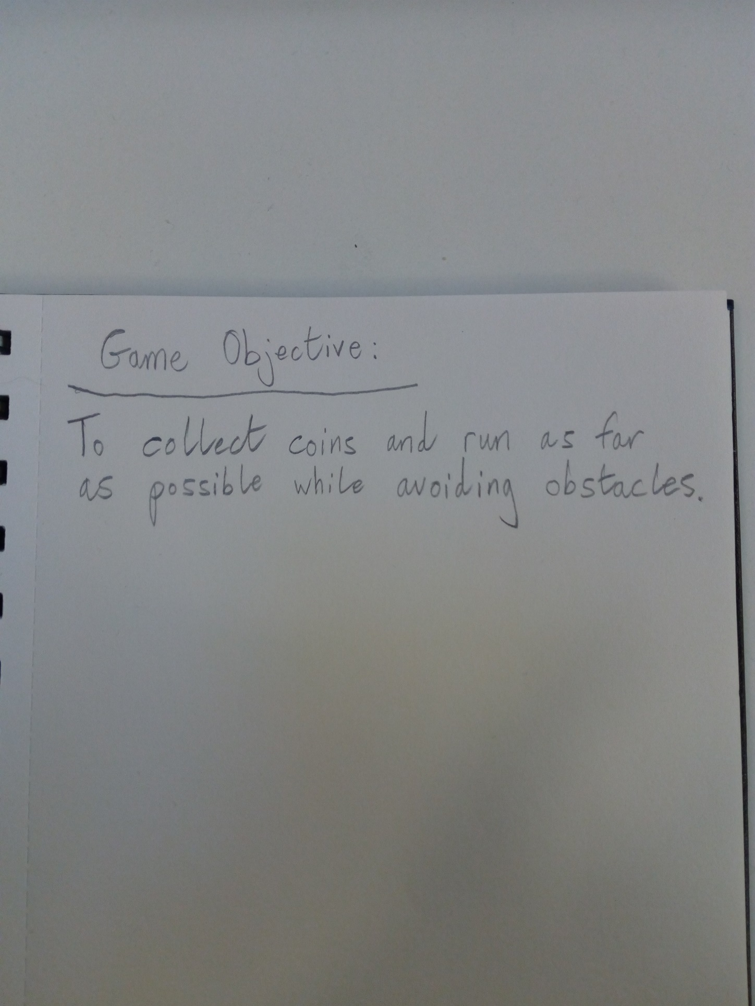

**Concept Sketches:**

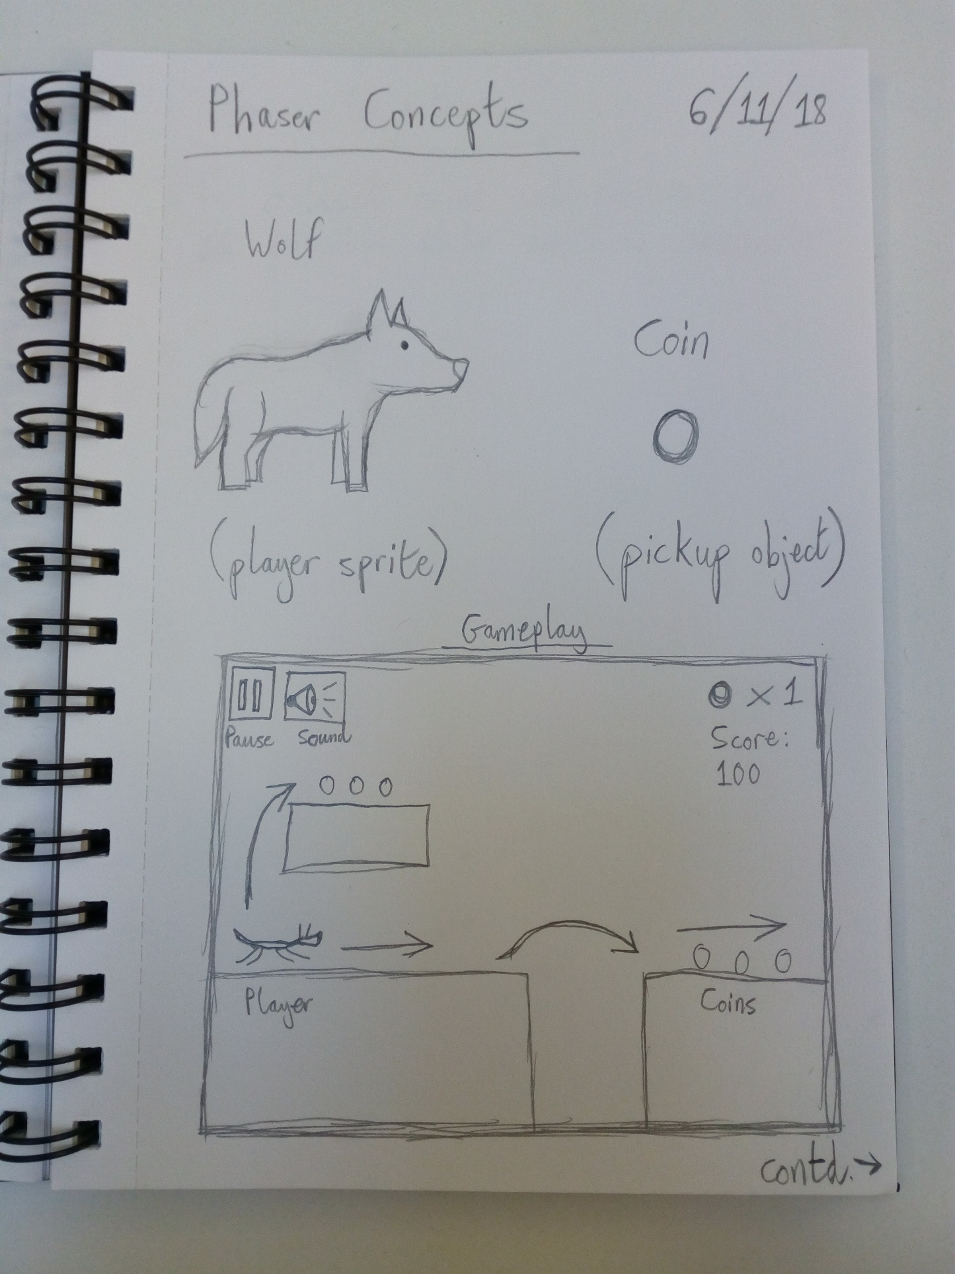

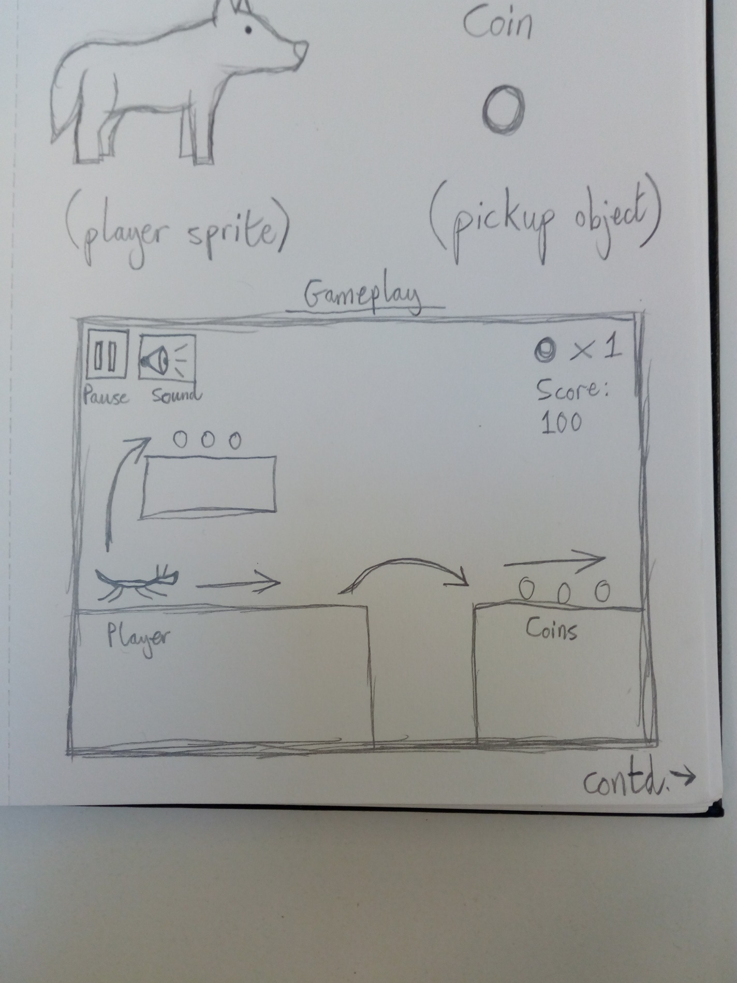

 Coin sprite (made in Pixilart.com)

**Sketched Level Design:**

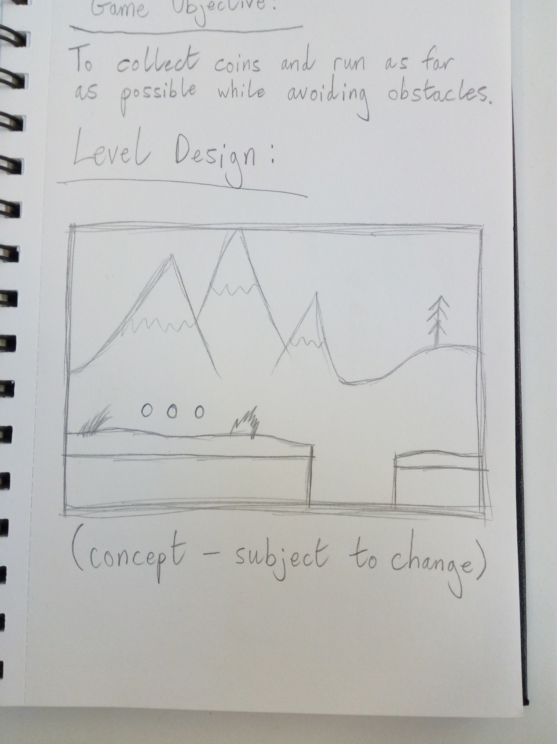

Sprite Ideas:

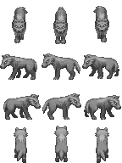 

*(Source:* [*https://www.deviantart.com/secretsigil/art/Wolf-Slender-Version-Grey-569493162*](https://www.deviantart.com/secretsigil/art/Wolf-Slender-Version-Grey-569493162) *,* [*https://graphicriver.net/item/2d-pixel-game-kit-5-of-5-w-character-sprites-more/16434122*](https://graphicriver.net/item/2d-pixel-game-kit-5-of-5-w-character-sprites-more/16434122)*)*

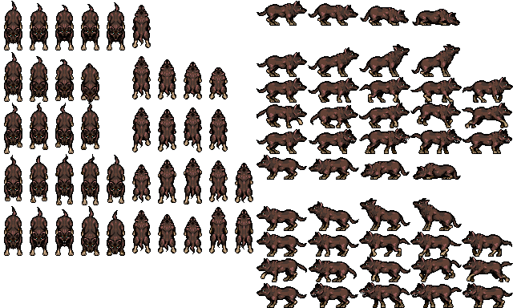

*(Source:* [*https://opengameart.org/content/lpc-wolf-animation*](https://opengameart.org/content/lpc-wolf-animation)*)*

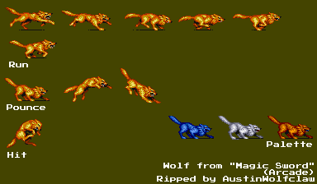

*(Source:* [*http://spritedatabase.net/file/19711/Wolf*](http://spritedatabase.net/file/19711/Wolf)*)*